Chapter17: circular motion
key points:
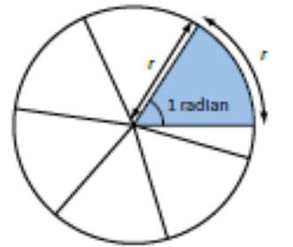
1.Radian: angle at the center of a circle by an arc of length equal to the radius.
Radian (rad) is the S.I. unit for angleθ and it can be related to degrees
in the following way. 360º= 2π(rad). 1rad=57.3º
2.angular displacement角位移（θ） unit:rad
As the object moves through an angle θ with respect to the centre of rotation, this angle θ is known as the angular displacement.
3.Angular velocity 角速度(ω) ： the rate of change of angular displacement of an object。 ω=Δθ/t=2π/T Unit:rad/s
(T is period =time taken for one complete revolution)
- (Linear )velocity线速度(v) is instantaneous velocity at any point in its circular path. v =arc length/time taken=2πr/T Uint:m/s
=rθ/t=rω ===> v=rω
The direction of the linear velocity is at a tangent to the circle at that point. Hence it is referred to as the tangential velocity.
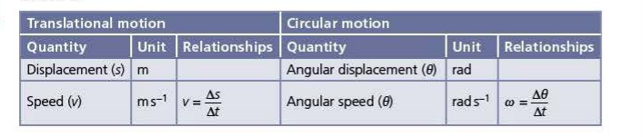
5. uniform circular motion匀速圆周运动:A body moving in a circle at a constant speed changes velocity (since its direction changes). Thus, it always experiences an acceleration, a force and a change in momentum.
6.Centripetal acceleration向心加速度 : unit:m/s²
a =rω²=v²/r, directed towards the center of circle
7.Centripetal force向心力： the resultant of all the specific forces directed towards the center of the circle and is at right angles to the (tangential) velocity. (Centripetal force is not a particular force“centripetal” ==“centre-towards”). unit；N
By ∑F=ma Centripetal force=mrω²=mv²/r (in magnitude)
点评：这章的重难点是对Centripetal force这个概念的理解。Centripetal force不是一个具体性质的力（重力，摩擦力等这些就是具体性质的力），而应该理解为各种具体性质的力在指向圆心方向的合效果。当力与速度方向相同，这样的力会让速度变大，称为动力。当力与速度方向相反，这样的力会让速度变小，称为阻力。而当力的方向与速度方向保持垂直，这样的力不会改变速度大小，只会改变速度方向，就称为向心力（Centripetal force）。 所以，在圆周运动的问题中，关键是要分析Centripetal force的来源，Centripetal force是由哪些指向圆心方向的具体性质的力或力的分量组合成的。
Examples 1：
A car cornering on a banked road (Figure a). Here, the normal contact force N has a horizontal component which can provide the centripetal force. The vertical component of N balances the car’s weight. Therefore:
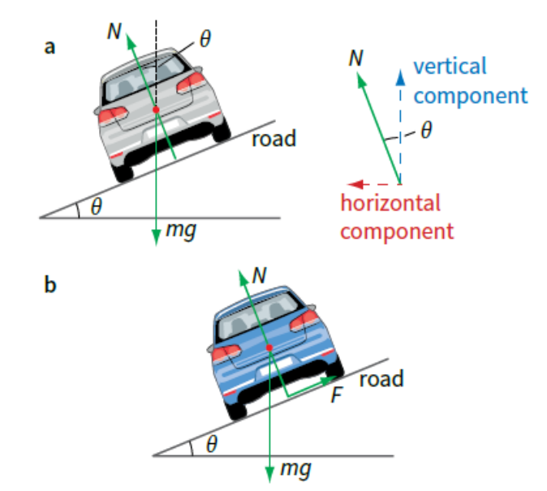
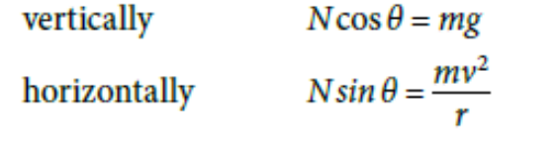
where r is the radius of the circular corner and v is the car’s speed.

拐弯的汽车受到重力mg和垂直斜面的支持力N，支持力N在竖直方向的分量和重力抵消，所以 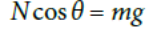，支持力N在水平方向的分量（也可看做重力和支持力的合力）就提供向心力 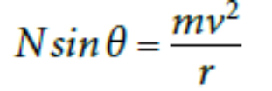。

Worked examples:

angle at the center of a circle by an arc of length equal to the radius.
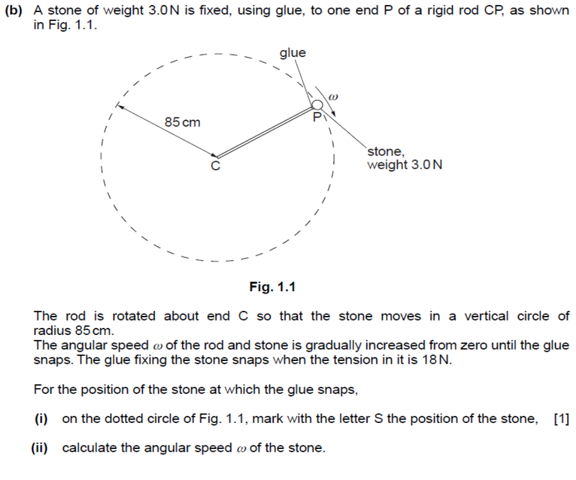
杆上的石头只受两个力 重力（weight）和杆施加的弹力（tension）,这两个力在指向圆心C点方向的合力提供向心力（centripetal force）。所以石头在圆轨道的最低点收到的弹力最大，
因为在最低点：tension ̶ weight= m r ω ²
Mark scheme:
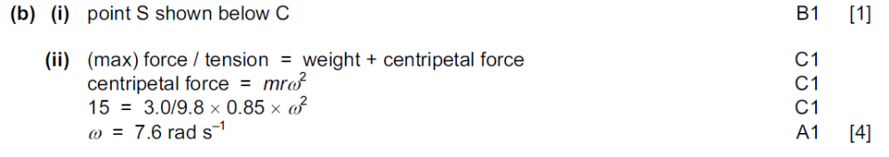

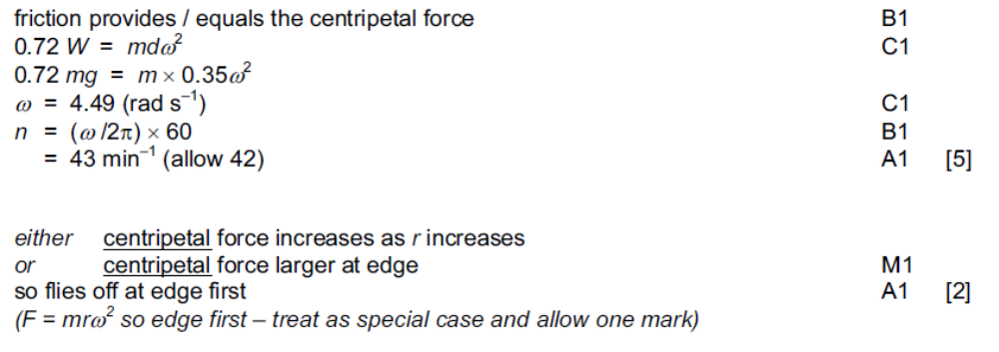
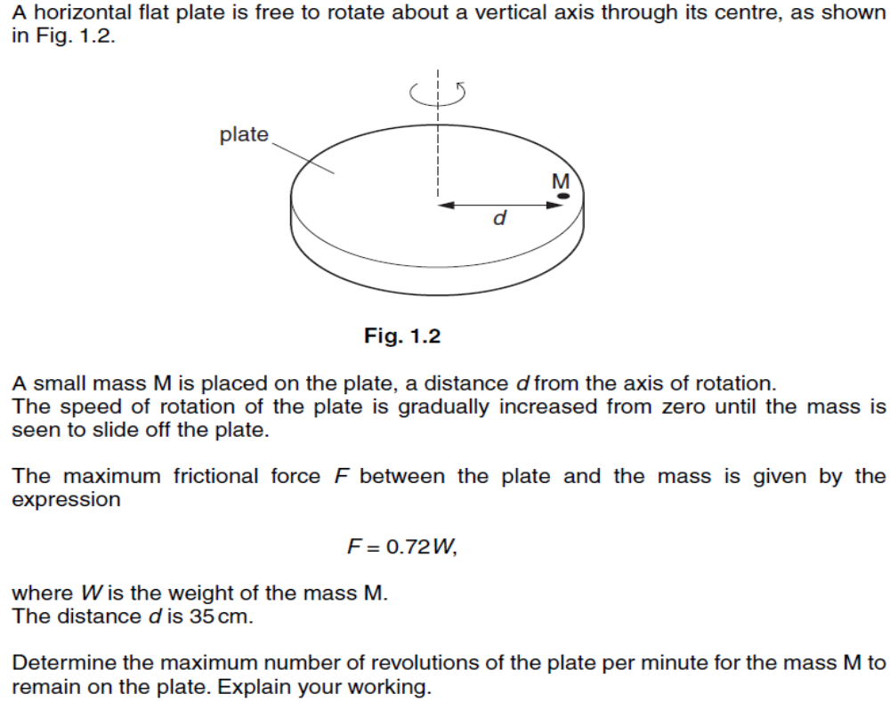
Q2:

分析小物体M的受力情况，平盘上的M受到一共三个力：重力，支持力和摩擦力。重力和支持力相互抵消了，三个力的合效果就是摩擦力，所以摩擦力提供向心力让物体做圆周运动，因此摩擦力大小等于m r ω ²,方向时刻指向圆心。随着转速的增加，ω要增加，要求摩擦力大小增加，当M即将滑动起来，摩擦力增加到最大值，所以有最大摩擦力0.72W= m r ω ²，半径r=d, ω就是物体M即将滑动时的最大角速度，对应着最大转速n=60f=60(ω/2π)(因为f=1/T, T=2π/ω )
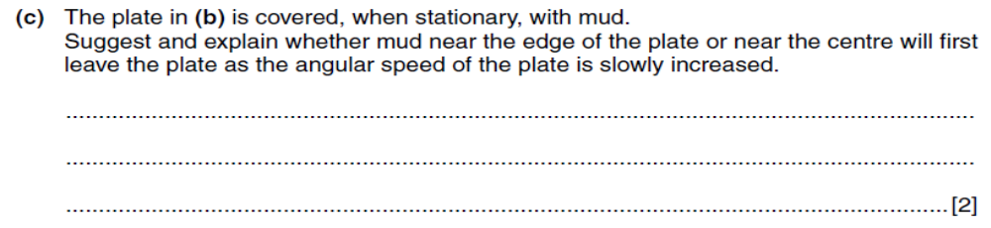
关键还是把握住是摩擦力提供的向心力，当维持圆周运动所需的向心力大于实际提供的摩擦力，物体就会离开圆轨道向圆外方向运动（叫离心运动）。圆轨道半径越大，向心力越大，所以边沿处的向心力先超过实际最大摩擦力，而实际最大摩擦力是个固定值。

Chapter18: Gravitational field
key points:
1.Newton's law of gravitation万有引力定律: the force between two point masses is directly proportional to the product of their masses and inversely proportional to the square of their separation.
Note： point masses M and m: separation r >> size of mass, so without consideration of the size, mass could be looked as a point
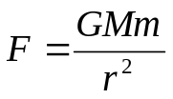

Universal gravitational constant G=6.67×10⁻¹¹Nm²kg⁻²
- for uniform sphere ,the entire mass of the sphere may be considered to be a point mass at its centre,
so r is the distance from the centre of sphere.
r m
mmmmmmmmmmmmm
M
- Gravitational field万有引力场 :a region of space force on mass
Gravitational field line show the Gravitational force direction on mass. the closer the field lines,the stronger the field.
- Gravitational field (strength)万有引力场强度g: g=F/m:force per unit mass at that point.
It is a vector and its S.I. unit is N kg^{-1.}
By definition g= F/m &Newton Law of Gravitation F = GMm / r²
==> g = GM/r², M = point Mass of object “creating” the field
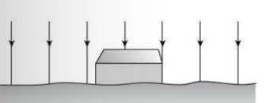
Note: nearby the Earth’s surface ,the distance from the Earth’s surface is much less than the radius of the Earth ,so it can be neglected,
Field lines are parallel and evenly spaced which shows the field is constant
r=the radius of the Earth, g=9.81 N kg⁻¹ ,
Gravitational field is uniform.

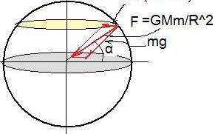
- If the Earth rotation is taken into account, centripetal force by earth rotation= mRω² (R is the radius of Earth, ω is the angular speed of earth rotation) is one small component of gravitational force, weight= mg is one large component of gravitational force.
On the Earth with mass M,
- At the Poles, Gravitational force=weight
so mg = GMm / R²
- At the equator, Gravitational force = centripetal force+weight
So mg= GMm / R²– mRω² (mRω² is so small that it can be negligible)

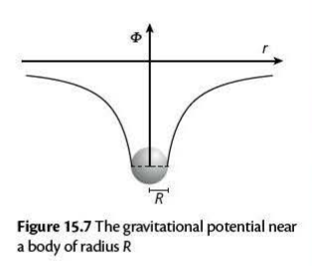
5.Gravitational potential万有引力势φ = W / m: work done per unit mass moving from infinity unit:J/kg c alculation point mass: φ= -GM / r
M
NOTE: all values of φ are negative. Because the gravitational force is attractive. And doing work when one object gets closer.so the G.p.e decreases from 0.the maximum G.p.e is 0 at infinity.

M = point Mass of object “creating” the field

6.Gravitational potential energy万有引力势能G.P.E=W=mφ = -GMm / r unit: J
Gravitational potential energyof a mass m at a point in the gravitational field of another mass M, is defined as the work done in bringing the mass m from infinity to that point.
Note: for a great distance must use: Change in GPE( ΔG.p.e) = mφ_{final}-mφ_{initial}
only if g is constant over the short distance nearby the Earth, because h<< radius of planet, h is negligible. ΔG.p.e = mgh(在地面附近的近似计算）
7.the relationship between field strength (g) and potential(φ)：
g=- dφ/dr = - gradient of potentia-distance graph
negative sign”—“means potential φ decreases in the direction of field strength g.
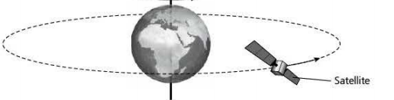
8.For a satellite in circular orbit"the centripetal force is provided by the gravitational Force" 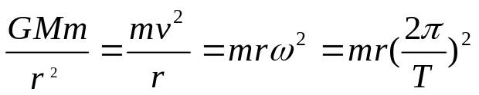 (around mass m”removed” ，M=centre Mass at the orbit)
v
m
M
r
T=2π /ω
ω
- Orbital speed v; By GMm / r² = mv² / r → v=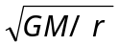
- min r =Radius of Earth ; so max V=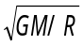=7.9km/s ( first cosmic speed第一宇宙速度)
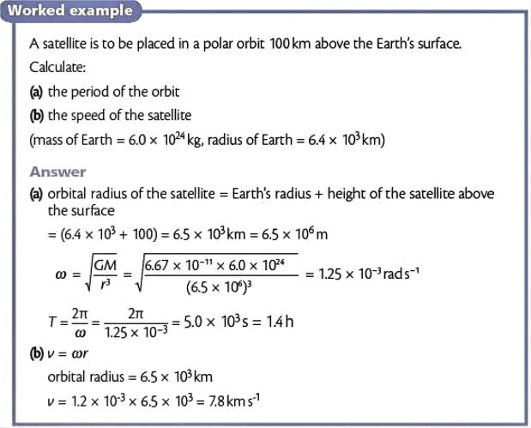
- Kepler's third law：r³/T²=constant∝M

9.Total Energy of a Satellite in orbit = GPE + KE=constant
By Conservation of Energy:
Initial KE | + | Initial GPE | = | Final KE | + | Final GPE
(½mv²) | + | (-GMm / r) | = | (0) | + | (0)
so ½mv²=GMm / r
Escape Speed of a Satellite v_{E} = 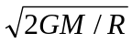 (the second cosmic speed 第二宇宙速度)
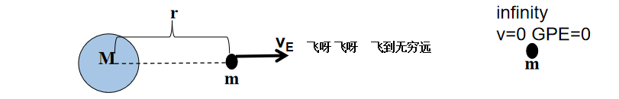
Worked example:
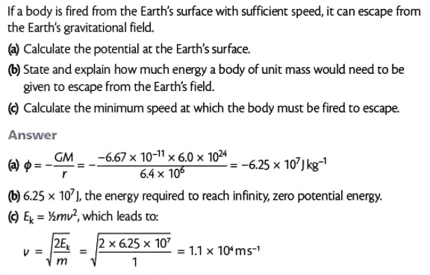
By Conservation of Energy: change in KE=Change in G.P.E
10.Geostationary satellite同步卫星 :A geostationary orbit must lie in the equatorial plane of the earth
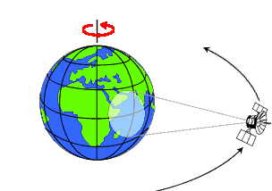
because the net force exerted on the satellite is the Earth's gravitational force, which is directed towards the centre of Earth.
From WEST to EAST
T = 24 h
- always above a certain point on the Earth equator
- Orbit period T = 24 hours
- rotation from west to east
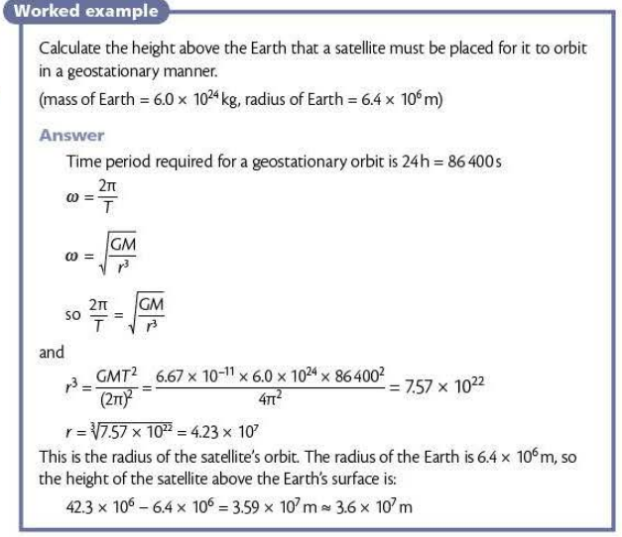

11.Understanding “weightlessness” :A person in a satellite orbiting the Earth experiences “weightlessness” the satellite would both have the same acceleration;they would experience gravitational force that works as centripetal force. hence the contact force between man & satellite is 0. normal reaction on the person is zero
(weight can be looked as an effect of pulling down by gravitational force)

点评：这章考试的重点主要是理解万有引力在天体运动中的应用。只要是天体的圆轨道运动，解题的思路都是“the centripetal force is provided by the gravitational force”。GMm/r²= mv²/r= mrω²= mr(2π/T)²这是天体圆轨道运动的基础，问题里的圆轨道运动的各种未知参数和关系都可列这个基本方程推导出。

Worked examples:
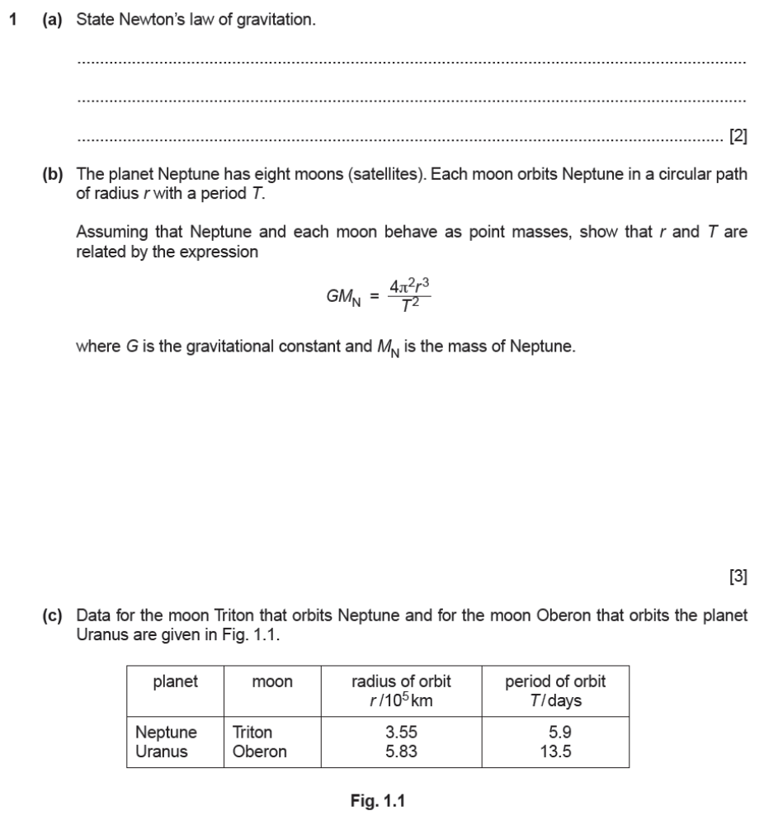
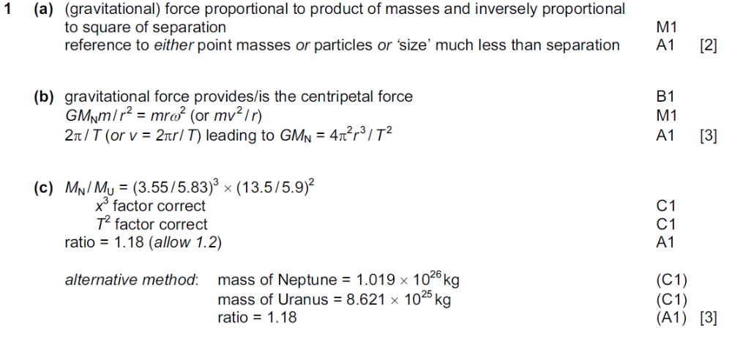

这是典型的天体圆轨道问题，解题思路 “the centripetal force is provided by the gravitational force”(Use key point 8)列方程GM_{N}m / r² = mr (2π / T)² ;因为题目要求证明r和T 的关系，所以用mr (2π / T)²这个表达式表示向心力。 M为卫星质量，在方程中可抵消掉。得到GM_{N} / r² =r (2π / T)² 推导出要证明的关系 GM_{N}=4π²r³/T² 注意M为轨道中心的天体的质量，而不是卫星质量。
Use key point 1
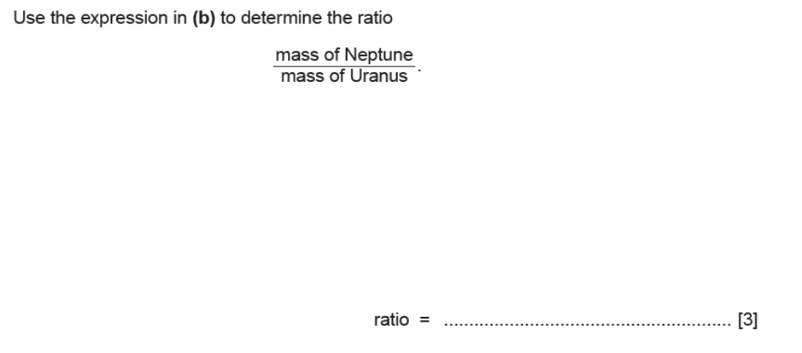
根据上面的关系式GM_{N}=4π²r³/T²，G，4π² 都是常量，
轨道中心的天体质量M(题中分别是Neptune and Uranus) 正比于 r³/T² ; r is radius of orbit ,T is period of orbit
根据题目中的数据 ：(3.55³/5.9²) /(5.83³/13.5²)

Q2.a
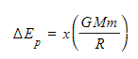
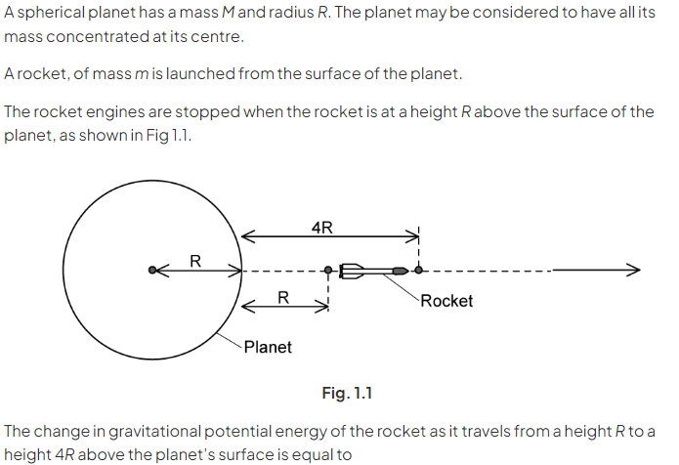
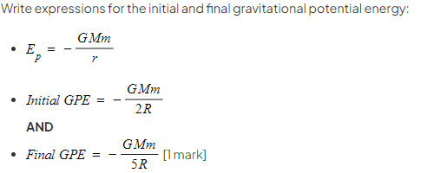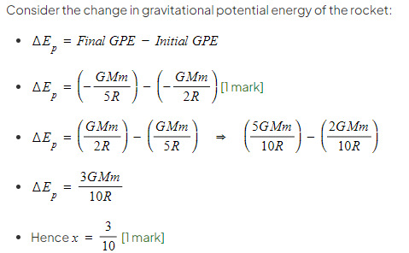
Q2.b

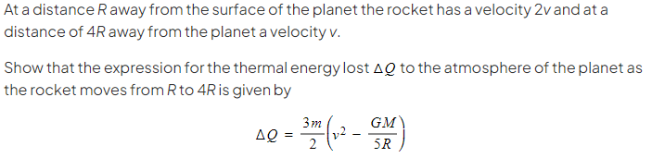
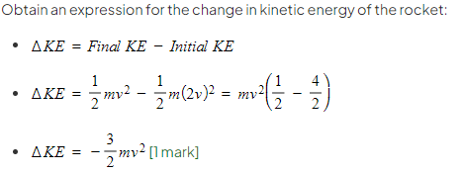
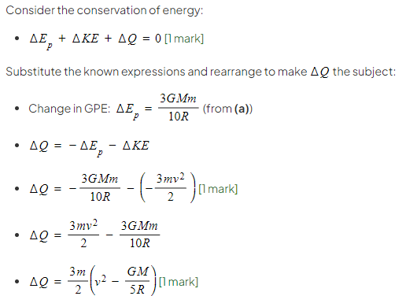
Q2.c
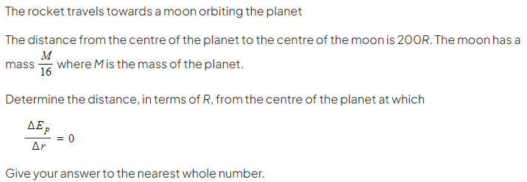
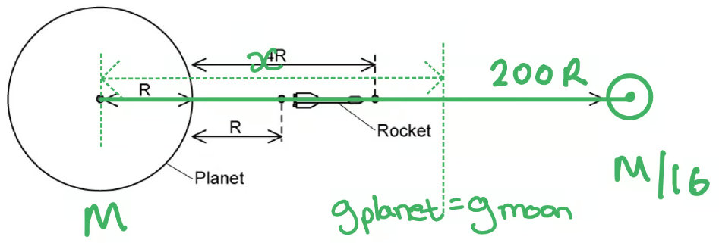
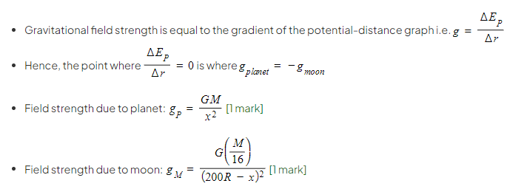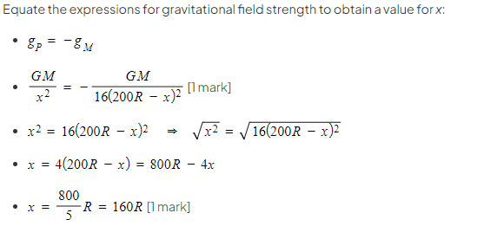
Q2.d
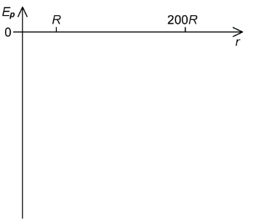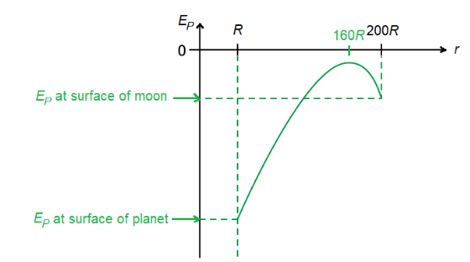
Q3 2022 sample questions
